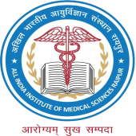 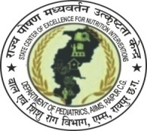 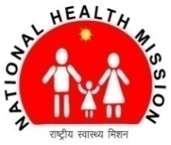  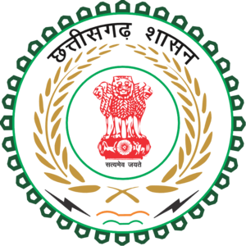 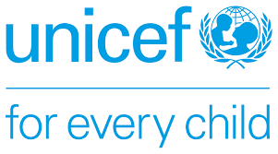

State Center of Excellence for Nutrition Interventions (SCoE4N)

Department of Pediatrics, AIIMS Raipur

IYCF

State Resource Center

Quarterly Report

July to September 2024

Contents

INTRODUCTION: 2

TELE-MENTORING: 2

PATIENT SUPPORT: 5

SUPPORTIVE SUPERVISION: 6

HOME VISITS: 7

STORY OF SUSHMA: 9

OUTREACH ACTIVITIES: 10

WAY FORWARD: 11

IYCF STATE RESOURCE CENTER

## INTRODUCTION:

State Center of Excellence for Nutrition Interventions (SCoE4N), Department of Pediatrics, AIIMS Raipur is supporting the Department of Women and Child Development (DWCD) and the child health division of Ministry of Health and Family Welfare (MoHFW) in strengthening the preventive strategies to child malnutrition i.e. Infant and Young Child Feeding (IYCF) through IYCF State Resource Center. This report discusses the progress made in the 3rd quarter of 2024.

## TELE-MENTORING:

Tele-mentoring of counselors (who are trained by SCoE4N on IYCF) is done to support them to initiate and sustain lactation counseling, to monitor the IYCF practices at facility level and to strengthen these practices at the facility and eventually in the districts. It is being conducted through IYCF Skill lab. Monthly schedule for Tele-mentoring session is being shared with counselors on regular basis. Report on findings is prepared on monthly basis and shared with stakeholders. Major findings from these sessions (Jul-Sept 2024) are as follows:

A total 58 Tele-mentoring sessions were completed between July and September.

Findings are as follows:

1. 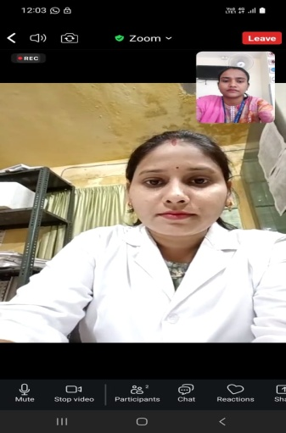**Network issue:** Observed at DH Korba & DH Narayanpur DH Korba, CHC Barhamkela District Sarangarh-Bilaigarh and CHC Bori, District Durg. Hence session was done over phone call.
2. 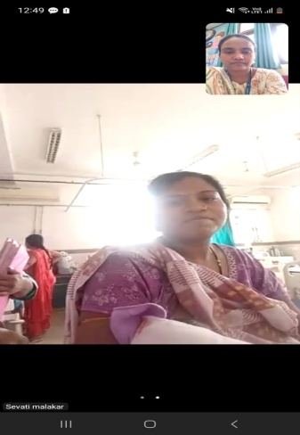**Irregular Counseling:** Most of the counselors informed that they take round of PNC ward and providing lactation counseling. At CHCs the delivery load has been less as compared to DH hence it was observed that better counseling was delivered. And instances of pre lacteal feeds and top feed were rare at CHCs. Counseling at some of the DHs was observed to be infrequent and less focused.

* Counselor from CHC Ambagarh Chowki told that she provides infrequent lactation counseling since she looks after NCD related counseling work. However she counsel mothers who come up with breastfeeding related issues.
* Counselor from CHC Mohla informed that he was not doing lactation counseling due to other work load hence he will not be able to attend Tele-mentoring session.
* Counselors from CHC Bori, District Durg, DH Surajpur and DH Balodabazar informed that they have high work load. They look after multiple programs; they do family planning counseling & procedures and ANC counseling along with lactation counseling.

1. **Issue of formula feed/top feed:**

* Counselor from DH Dantewada informed that when deliveries happen at night, formula feeds were observed in the ward during morning rounds. She told that some families brought formula on their own or asked for formula feed from SNCU. A few families brought cow milk as well.
* Counselor from Medical College Bilaspur told that she was finding it difficult to counsel all the mothers since the daily delivery load has been around 20-25 which includes many C-Sections. She informed that very few Staff Nurses provide support in lactation counseling. She also informed that last night (2nd September 2024) 2-3 families brought formula feed and it was prescribed by interns.
* Counselor from DH Koria told that families do not cooperate and give top feed even after counseling. She also informed that some mothers do not eat properly (only bread, biscuit or tea) for 3-6 days post delivery.

1. **Good Practices:**

* Use of Audio-Visual aid at DH Dantewada. There was TV and a pen drive with videos on it which was used to play videos in the ward which supports counseling.
* Staff at the NICU, Medical College, Bilaspur were working to ensure breastfeeding. Infants admitted in the NICU were given expressed breast milk using syringes.
* At CHC Tokapal District Bastar, it was observed that mothers used the mosquito nets which is a good preventive strategy followed in the district.

1. In the month of July we initiated the concept of “Counselor of the Month” in order to motivate the counselors and recognize their efforts. Counselors who have been regular in attending the tele-mentoring sessions and have been providing regular lactation counseling were selected.
   1. Ms Jyoti from DH Dhamtari was selected for the month of July
   2. Ms Kiran from DH Kondagaona and Ms Radhika from CHC Tokapal, District Kondagaon were selected for the month of August.
   3. Ms. Sabina Bhagat, CHC Sonhat, District Korea was selected in September.

During these sessions we connected to mothers admitted in the PNC ward with support from counselors. Total 46 mothers were interviewed. Following are some of the key findings from these discussions (Table No. 1).

Table No. 1: Findings

|  |  |  |  |  |
| --- | --- | --- | --- | --- |
| **S.No** | **Indicators** | **Response** | | **Remarks, if any** |
| **Yes** | **No** |
| 1 | Whether mother breastfed the baby within one hour of delivery | 35 | 11 | Delay in initiation of breastfeeding was observed due to  -Child’s or mother’ s illness  -Shifting from OT to PNC ward  -One mother did not initiate breastfeeding due to flap nipple. Later the child developed Jaundice.  -Another Child was born premature and was admitted.  -In one case child had low birth weight and mother was not having any milk even after massage (as informed by counselor). Child was given breast milk of other mother. |
| 2 | Whether baby was given colostrums | 45 | 1 | Colostrum was not given in one case because mother did not have any breast milk for a couple of days. |
| 3 | Whether mother is currently breastfeeding | 40 | 6 | Out of the 6 children who were not on exclusive breastfeeding, 5 were on mix feed and 1 was on formula feed completely. |
| 4 | Whether any pre lacteal is given | 8 | 38 | Formula feed was given as pre lacteal feed. . Use of no other type of pre lacteal feed was informed. Reasons for formula feed as informed by mother  -Insufficiency of breast milk  -Child was admitted to NBSU/SNCU |
| 5 | Whether mother received counseling on breastfeeding | 38 | 6 | - |

**Action Points**

1. On site orientation of Staff Nurses of DH Mahasamund (Focused district)
   1. Orientation was done on 3rd August 2024.
2. Provide supportive supervision through field visits, in the focused districts (MMAC and Mahasamund
   1. Supportive supervision visit done at DH Mahasamund on 26th July 2024 and CHC Mohla on 7th August 2024
   2. Supportive supervision visit done at CHC Ambagarh Chowki on 4th September 2024
3. Take support from DNCs to identify lacunae and develop plan to overcome the challenges.
4. Facilitate dissemination of Tele-mentoring reports to the districts**.**
5. Rationalization of workload should be done so that they can effectively perform their duties.

## PATIENT SUPPORT:

Comprehensive counseling services are provided under IYCF State Resource Center, SCoE4N. Table no. 2 presents the month wise data of these counseling sessions.

Table No. 2: Counseling Data

|  |  |  |  |  |  |  |
| --- | --- | --- | --- | --- | --- | --- |
| **Counseling Services** | | | | | | |
| Month | PNC Ward | | | ANC Ward | Office | |
| No. of mothers given interpersonal counseling | Total counseling conducted | No. of mothers counseled through group sessions (Average value) | No. of mothers counseled | ANC Counseling done | IYCF Counseling done |
| July | 36 | 180 | 120 | 485 | 3 | 32 |
| August | 98 | 190 | 150 | 307 | 1 | 32 |
| September | 45 | 182 | 120 | 448 | 2 | 31 |
| **Total** | **179** | **552** | **390** | **1240** | **6** | **95** |

Rate of early initiation of breastfeeding in the month of June 2024 was 67% however following three month of comprehensive counseling it was found to at 76% in the month of October 2024.

## SUPPORTIVE SUPERVISION:

**PNC Ward visit**

A total 84 visits were done between July and September 2024 at DH, CHCs & few Primary Health Centers. Distribution of facility visited is depicted in graph.

99% of the facilities have a functional weighing scale whereas 95% facilities were found to be taking weight of newborns immediately after birth. A total 78 Low birth weight newborns were present at the time of supervision whereas 67 (86%) of these were supported in doing KMC. 55 of the total facilities had RMNCH counselors, out of which 45 (82%) were reported to provide support in breastfeeding counseling.

A total of 232 mothers admitted in the PNC wards were interviewed during this visit. Following graphs presents the demographic and birth details.

Status of early initiation of breastfeeding (as informed by mothers) and pre lacteal feed is presented in the graph below. Mothers who delivered through C-section, only 19% of them reported that they breastfed the babies within one hour of delivery. However another 22% of these mothers initiated breastfeeding between 1 to 6 hours. Total 6% of mothers reported that they gave pre lacteal feed to the baby. Out of these, 53% of them reported giving formula feed.

A total of 25% mothers reported facing one or the other issues related to breastfeeding. 81% of them reported that there problems were resolved by service providers. Also out of all the mothers who delivered through C-section 83% reported receiving help for initiating breastfeeding. 76% of total mothers reported that they have received counseling on breastfeeding during Ante Natal period.

## HOME VISITS:

**Lactating mothers**

A total of 539 lactating mothers were interviewed between July to September 2024. Following graphs presents the demographic details.

98% of 0 to 6 months children were receiving breastfeeding. 91% of children were found to be on exclusive breastfeeding, whereas 9% were given some food/liquid items. A total 92% of these children were breastfed at night. Frequency of breastfeeding of children is shown in graph.

94% mothers reported that they have received Take Home Ration from Anganwadi Centers however only 24% of these mothers reported its consumption all by her. Rest was consumed in sharing with the rest of the family or not consumed at all.

**Diet Audit (of children <2 years)**

A total of 360 households with children in the age group of 6 to 23 months were visited between July to September 2024. After data cleaning, analysis of 327 diet audits is discussed here. 41% of the mothers/care takers interviewed reported timely initiation of complementary feeding (after completion of 6 months of age) for their children. 46% reported delayed initiation while 14% reported early initiation of complementary feeding. 84% of the children between 6-8 months were on breastfeeding and given semi solid/solid foods. Breastfeeding children between 9 to 23 months of age, 19% were receiving an adequate diet (Semi solid/solid food given thrice or more including food items from at least 4 food groups along with breast milk). 98% families reported one or more type of packaged food is given to the child. Status of other feeding practices (Children between 6 to 23 months of age) is presented in graph below.

**(N=412)**

(GRAPH NO. 3)

89% of the children aged 9 to 23 months reported to have been given Vitamin A in the past 6 months. Only 35% of the families of children aged 6 to 23 months reported that they have received IFA syrup and a regularly giving to their children. 15% families reported that they received the syrup but do not give it or give it irregularly where 50% families reported that either they have not received the syrup or they do not remember it.

## STORY OF SUSHMA:

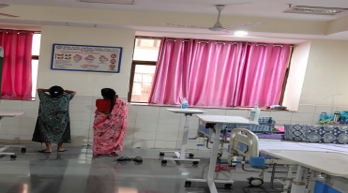A primi mother aged 27 years had premature twin delivery at AIIMS Raipur. Both twins were low birth weight (1.39 kg and 1.4 kg). Both twins were admitted to NICU immediately after delivery.

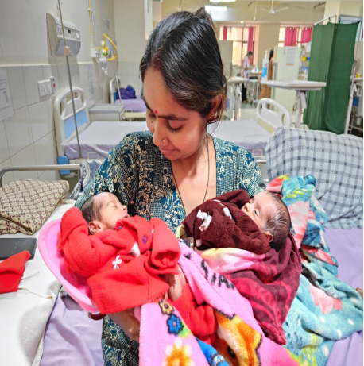In the PNC ward, she was given lactation counseling emphasizing on milk expression and Kangaroo Mother Care (KMC). She was supported to express breast milk and send it to NICU. She was continuously motivated to express milk. This ensured optimal feed for the newborns and also helped in Let Down reflex. Eventually mother started visiting NICU for KMC. After 10 days both twins were shifted to PNC ward. Mother was then counseled and supported on good attachment and breastfeeding positions. Our lactation counselor demonstrated football hold position. Mother felt confident and started breastfeeding both newborns.

One day mother spoke to a relative over phone. The relative advised her to draw a religious sign on the tongue of the twins using honey. The relative claimed it will improve their physical and mental growth. Our lactation counselor came to know about such absurd advice while speaking to the mother. She immediately responded to this and counseled the mother on harms of such an act. Mother was also asked to read the IEC materials in the ward during her free time and do not accept any advice given by people other than her healthcare providers. With constant support and a strong will power mother continued breastfeeding the twins and did not resorted to bottle feed. On follow up she informed that both twins were on exclusive breastfeeding.

The threat of misinformation shall not be underestimated. Listening carefully to the mothers description, her apprehensions is a crucial part of inter personal counseling. Timely and effective counseling of mothers and families is an important strategy at SCoE4N and such experiences are a testimony of its benefits.

## WhatsApp Image 2024-08-01 at 11.10.31.jpegOUTREACH ACTIVITIES:

1. World Breastfeeding Week Celebration

In the month of August World Breastfeeding Week was celebrated at various Health Facilities across the state. Following activities were done through SCoE4N.

1. Inaugural Event at AIIMS Raipur
   * 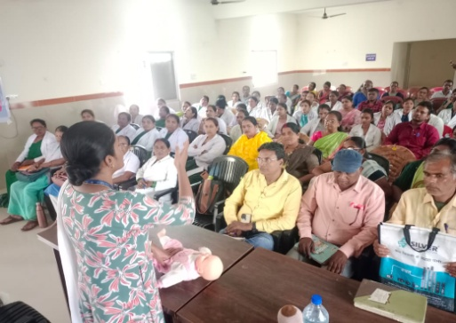Role play
   * Demonstration using manequin
   * Felicitation of selected mothers
2. State level Webinar on breastfeeding
3. Group counseling ANC, PNC ward & Pediatric OPD, AIIMS Raipur
4. 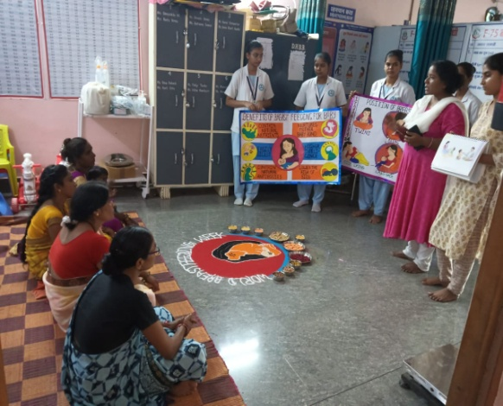Orientation of Nursing Officers District Hospital Mahasamund
5. Orientation of ANM, RHO, CHO, Supervisors of Mohla
6. Health Talk at All India Radio
7. 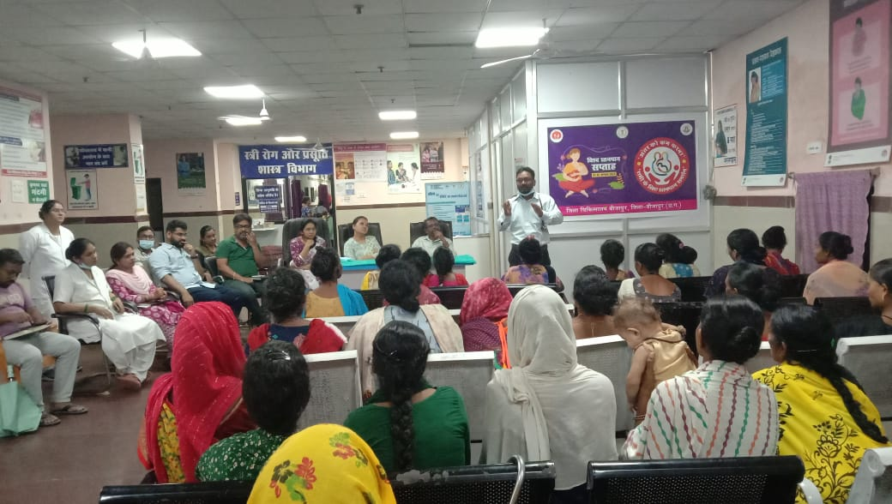District Nutrition Coordinators (DNC) and Block Nutrition Coordinators (BNC) supported district level events on Anganwadi Centers, Health Facilities etc. These events were also celebrated as part of the Community Based Events.

Nursing officers and counselors who were trained by SCoE4N in the previous quarters also shared glimpses of activities that were celebrated at their respective health facilities.

1. Poshan Maah

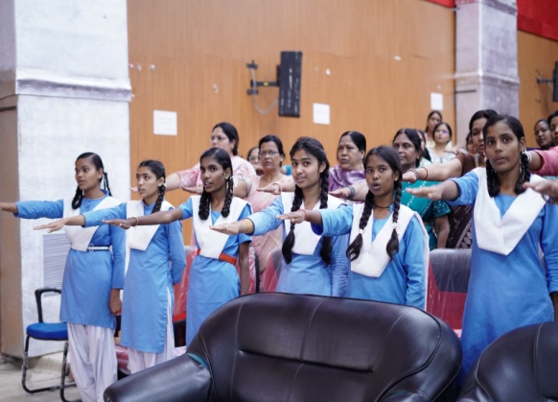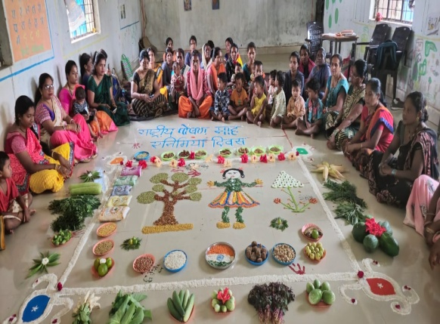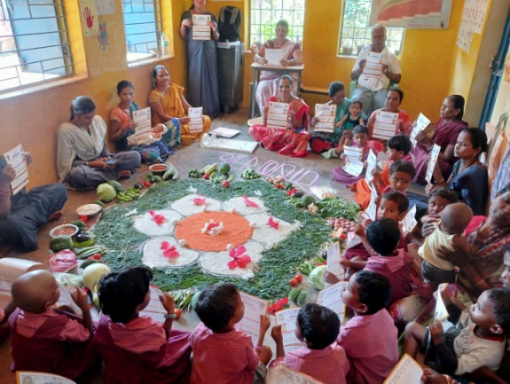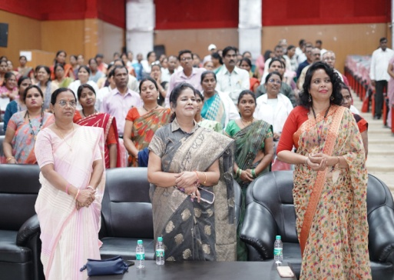Month of September is celebrated as Poshan Maah. Our DNCs and BNCs supported district level events on the same throughout the month. A one day seminar on IYCF was organized at Janjgir-Champa district. Over 400 participants from Department of Woman and Child Development and Health Department participated in the event. School teachers and Students were also in attendance of the webinar.

## WAY FORWARD:

1. Review meeting of counselors under MAA program.
2. Strengthen lactation counseling during ANC period, emphasizing the importance and feasibility of early initiation of breastfeeding after a C-section.
3. Orientation of Medical Officers and interns to discourage formula feed.
4. Support state level training of Nursing Officers.
5. Continue hand holding of Anganwadi Workers through training and supportive supervision visits by DNC/BNCs.
6. Behavior Change Communication to bring in change in the following:
   1. Regular consumption of Take Home Ration only by the intended beneficiaries
   2. Timely initiation of complementary feeding (rice eating ceremony) of infants
   3. Diet diversity
   4. Avoiding packaged food
   5. Adding oil on top of food
7. Advocate for regular supply of IFA syrup and monitoring of its distribution by frontline workers.

**Prof.(Dr.) Anil Kumar Goel**

Programme Director

SCoE4N Programme

Professor Head, Department of Pediatrics,

AIIMS Raipur.

----End of Report-----